**What is Data Structure?**

*A*[*data structure*](https://www.geeksforgeeks.org/data-structures/)*is a particular way of organising data in a computer so that it can be used effectively. The idea is to reduce the space and time complexities of different tasks.*

The choice of a good data structure makes it possible to perform a variety of critical operations effectively. An efficient data structure also uses minimum memory space and execution time to process the structure. A data structure is not only used for organising the data. It is also used for processing, retrieving, and storing data. There are different basic and advanced types of data structures that are used in almost every program or software system that has been developed. So we must have good knowledge of data structures.

**Need Of Data Structure:**

The structure of the data and the synthesis of the algorithm are relative to each other. Data presentation must be easy to understand so the developer, as well as the user, can make an efficient implementation of the operation.  
Data structures provide an easy way of organising, retrieving, managing, and storing data.

Here is a list of the needs for data.

* Data structure modification is easy.
* It requires less time.
* Save storage memory space.
* [Data representation](https://www.geeksforgeeks.org/what-are-the-different-ways-of-data-representation/) is easy.
* Easy access to the large database

**Classification of Data Structure:**

Data structure has many different uses in our daily life. There are many different data structures that are used to solve different mathematical and logical problems. By using data structure, one can organize and process a very large amount of data in a relatively short period. Let’s look at different data structures that are used in different situations. 

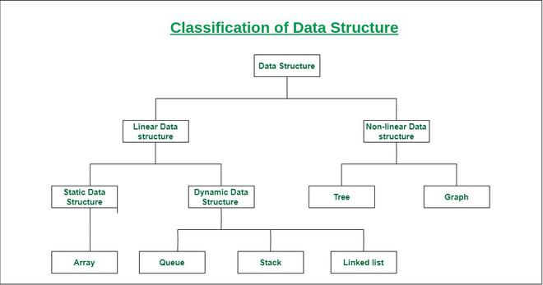

* **Linear data structure:** Data structure in which data elements are arranged sequentially or linearly, where each element is attached to its previous and next adjacent elements, is called a linear data structure. Elements are arranged in one dimension ,also known as linear dimension.   
  *Examples of linear data structures are array, stack, queue, linked list, etc.*
  + **Static data structure:**Static data structure has a fixed memory size. It is easier to access the elements in a static data structure.   
    *An example of this data structure is an array.*
  + **Dynamic data structure:**In the dynamic data structure, the size is not fixed. It can be randomly updated during the runtime which may be considered efficient concerning the memory (space) complexity of the code.   
    *Examples of this data structure are queue, stack, etc.*
* **Non-linear data structure:**Data structures where data elements are not placed sequentially or linearly are called non-linear data structures. In a non-linear data structure, we can’t traverse all the elements in a single run only. Elements are arranged in one-many, many-one and many-many dimensions.

*Examples of non-linear data structures are trees and graphs.*

**Array**

* An array is a linear data structure and it is a collection of items stored at contiguous memory locations. The idea is to store multiple items of the same type together in one place. It allows the processing of a large amount of data in a relatively short period. The first element of the array is indexed by a subscript of 0. There are different operations possible in an array, like Searching, Sorting, Inserting, Traversing, Reversing, and Deleting.

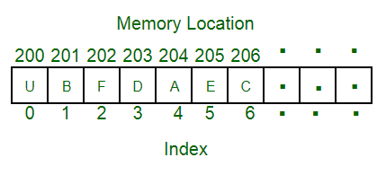

**Characteristics of an Array:**

* An array has various characteristics which are as follows:
* Arrays use an index-based data structure which helps to identify each of the elements in an array easily using the index.
* If a user wants to store multiple values of the same data type, then the array can be utilized efficiently.
* An array can also handle complex data structures by storing data in a two-dimensional array.
* An array is also used to implement other data structures like Stacks, Queues, Heaps, Hash tables, etc.
* The search process in an array can be done very easily.

**Operations performed on array:**

* **Initialization**: An array can be initialized with values at the time of declaration or later using an assignment statement.
* Accessing elements: Elements in an array can be accessed by their index, which starts from 0 and goes up to the size of the array minus one.
* **Searching for elements**: Arrays can be searched for a specific element using linear search or binary search algorithms.
* **Sorting elements**: Elements in an array can be sorted in ascending or descending order using algorithms like bubble sort, insertion sort, or quick sort.
* **Inserting elements:**Elements can be inserted into an array at a specific location, but this operation can be time-consuming because it requires shifting existing elements in the array.
* **Deleting elements:** Elements can be deleted from an array by shifting the elements that come after it to fill the gap.
* **Updating elements:** Elements in an array can be updated or modified by assigning a new value to a specific index.
* **Traversing elements:** The elements in an array can be traversed in order, visiting each element once.
* These are some of the most common operations performed on arrays. The specific operations and algorithms used may vary based on the requirements of the problem and the programming language used.

**Applications of Array:**

* Different applications of an array are as follows:
* An array is used in solving matrix problems.
* Database records are also implemented by an array.
* It helps in implementing a sorting algorithm.
* It is also used to implement other data structures like Stacks, Queues, Heaps, Hash tables, etc.
* An array can be used for CPU scheduling.
* Can be applied as a lookup table in computers.
* Arrays can be used in speech processing where every speech signal is an array.
* The screen of the computer is also displayed by an array. Here we use a multidimensional array.
* The array is used in many management systems like a library, students, parliament, etc.
* The array is used in the online ticket booking system. Contacts on a cell phone are displayed by this array.
* In games like online chess, where the player can store his past moves as well as current moves. It indicates a hint of position.
* To save images in a specific dimension in the android Like 360*1200

**Real-Life Applications of Array:**

* An array is frequently used to store data for mathematical computations.
* It is used in image processing.
* It is also used in record management.
* Book pages are also real-life examples of an array.
* It is used in ordering boxes as well.